Revisions; class 6

### 1/ Layers

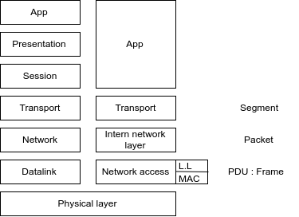

### 2/ Physical layer

Frequencies depend on the bandwidth.

You can have the same frequencies, but different datas.

**Bit rate** = number of bits per sec.

**baud rate** = number of discret symboles per sec.

2 types of limits (all physical):

* baud rate limit => shannon formula
* bit rate limit => S/N

### 3/ DataLink Layer

Question 2

a/ yes

b/ if x < 0,6us > collision

0,6 < x < 1,2 > differs

1,2 < x > idk (depends lenght)

1st : (0,1) T : 2

2nd : (0,1,2,3)T : 2²

3rd : (0,1,2,3,4,5,6,7)T : 2^3

P(A) = ¼

P(B) = ⅛

4x ¼ x ⅛ = 12.5%

4/ Network layer

Network Part on 8/16/24 bits

With subnets there is no limit.

eg : campus is a class A network. There is 20bits for the Network port, and 12 bits for the device port.

On the device port, you have : 2^12 - 2 : Network address and broadcast address

Exercice 4 :

Class C;

If mask = 24, we have : 11111111 11111111 11111111 (24x1) for the network part

and 00000000 for host

25 : 11111111 11111111 11111111 10000000

26 : 11111111 11111111 11111111 11000000